
FACULTY OF SCIENCE AND COMPUTING
DEPARTMENT OF COMPUTING
GROUP MEMBER | REGISTRATION NUMBER
ATIM CAROLINE | 23/1/370/D/238
NAKASIGA IMMACULATE M | 23/1/370/D/217

Agri Connect: A Fault-Tolerant Distributed Produce Exchange

Abstract
AgriConnect is a small distributed service that helps Ugandan farmers sell produce directly to buyers, with transporters moving the goods in between. It keeps working when one of its server processes dies, and when nothing can serve requests, it says so plainly instead of hanging.
A React browser client talks over HTTP/REST to a Node.js load balancer. The balancer forwards each request to one of two Django REST API processes, which share a single database, so neither process holds data the other lacks. Database transactions and conditional updates stop two people from buying the same sack of maize or claiming the same delivery. A health endpoint lets the balancer skip a dead process. Six automated tests cover permissions, health reporting, stock conflicts and delivery claims, and a 100-request benchmark was run at one and ten concurrent clients on a single laptop.
This is a teaching prototype. It has one proxy, one primary database and no queue for requests that arrive during an outage. We say where those limits bite in Sections 4 and 7.

Introduction
Smallholder farmers in Uganda often sell through middlemen because finding a buyer, agreeing a price and arranging transport is hard to do directly. We chose this problem because it is naturally distributed: many people, on different devices, read and change the same records at the same time. Two buyers can want the last 40 kg of tomatoes in the same second, and the system has to give it to exactly one of them.
The brief asks for a prototype that lets multiple clients submit, retrieve and update records, and that keeps giving useful service when a server process fails. The sections below follow the brief's tasks (a) to (f): requirements and architecture, implementation, coordination, fault handling, performance, and testing with a demonstration plan.

1. Requirements and architecture

1.1 Who uses the system
Four kinds of people use AgriConnect, and the server (not the browser) decides what each may do. Hiding a button in the interface is not security, so every role check is enforced in the API and returns 403 Forbidden when a role tries something it should not.
User | What they do
Farmer | Publishes produce, reviews purchase requests, accepts or rejects them, updates order status
Buyer | Browses and filters produce, requests a quantity, follows the payment status and tracks the order
Transporter | Finds open deliveries, claims one, reports pickup, transit and delivery
Administrator | Verifies users, moderates listings, inspects orders and deliveries nationwide
Public sign-up accepts only farmer, buyer and transporter roles, so nobody can make themselves an administrator. Administrator accounts are created by an existing administrator or with Django's createsuperuser command.

1.2 Processes, components and links
Component | Technology | Role
Client | React + Vite, in the browser | Role-specific dashboards; sends REST/JSON with a JWT bearer token
Load balancer | Node.js, port 8080 | Single address for the client; probes each API node about once a second and forwards requests to a healthy one
API node "primary" | Django REST Framework, port 8001 | Serves the API; preferred whenever it is healthy
API node "standby" | Django REST Framework, port 8002 | Identical code; takes over when the primary is down
Database | Local SQLite as primary, Supabase PostgreSQL as synchronized backup | Shared source of truth for both API nodes
The prototype runs on one Windows laptop with Python and Node.js and needs no containers. All links are HTTP between processes (HTTPS would be used in a real deployment) and SQL between the API nodes and the database.

1.3 Functional requirements
- Role-based records. Authenticated users create, retrieve and update only the records their role allows.
- Marketplace. Buyers find active listings and request an available quantity; a farmer accepting a request turns it into an order.
- Delivery. A transporter claims an open delivery and reports its progress; the buyer and seller can follow it.
- Oversight. Administrators verify users and see all marketplace and delivery records.
- Survival of a node failure. If one API process fails, requests are served by another; if none is healthy, the client gets an explicit 503 response.

1.4 Architecture
Figure 1 shows how the parts connect. The browser only ever knows one address; the two API nodes behind it are interchangeable because neither keeps its own copy of the data.
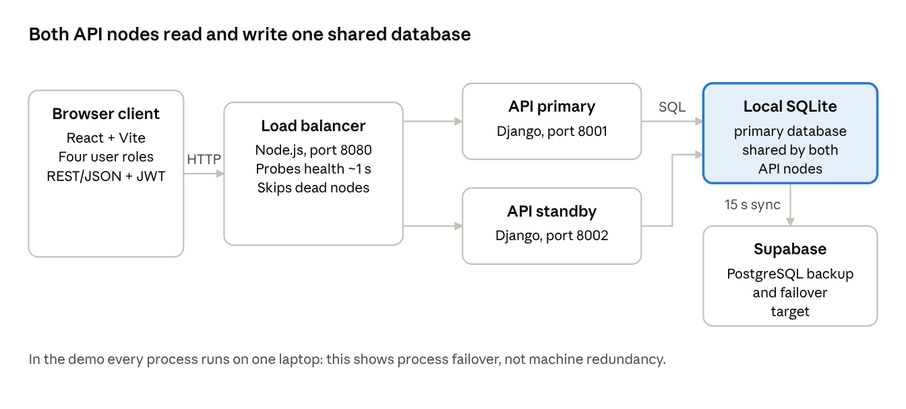
Figure 1 · AgriConnect architecture, 5 components
Figure 1. Requests flow from the browser to the load balancer, then to whichever API node is healthy, and every node reads and writes the same database. Local SQLite is the primary; Supabase PostgreSQL holds a synchronized backup that the system can switch to.

2. Implementation
The client and the API talk over HTTP using REST and JSON. After signing in, a user receives a JWT that the browser attaches to every later request, so any API node can verify who is calling without sharing session memory. That is what makes the two nodes interchangeable.
A typical trade shows how data moves through the system:
- A farmer posts a listing (crop, quantity, price, district). The API writes it to the shared database.
- A buyer filters listings by district or crop and submits a request for a quantity.
- The farmer accepts. The API creates an order and, if the buyer asked for transport, a delivery. A buyer can also pick a preferred transporter.
- A transporter claims the open delivery, then moves it through accepted, picked-up, in-transit and delivered.
- The buyer and seller see each status change on their dashboards, and notifications are written alongside each step.
Administrators see a verification queue and national order and delivery views. Payment is modelled as a status on the order. It does not connect to a real payment provider, and we flag that as a prototype simplification.
The API is built with Django REST Framework and exposes health, authentication, marketplace, order, delivery, notification and administration endpoints. Setup needs only Python and Node.js: install backend/requirements.txt, run the Django migrations, optionally seed demo data, start runserver twice on ports 8001 and 8002 with different AGRI_NODE_ID values, then run npm run load-balancer and npm run dev from frontend. Full steps, including the Supabase backup, are in the README.
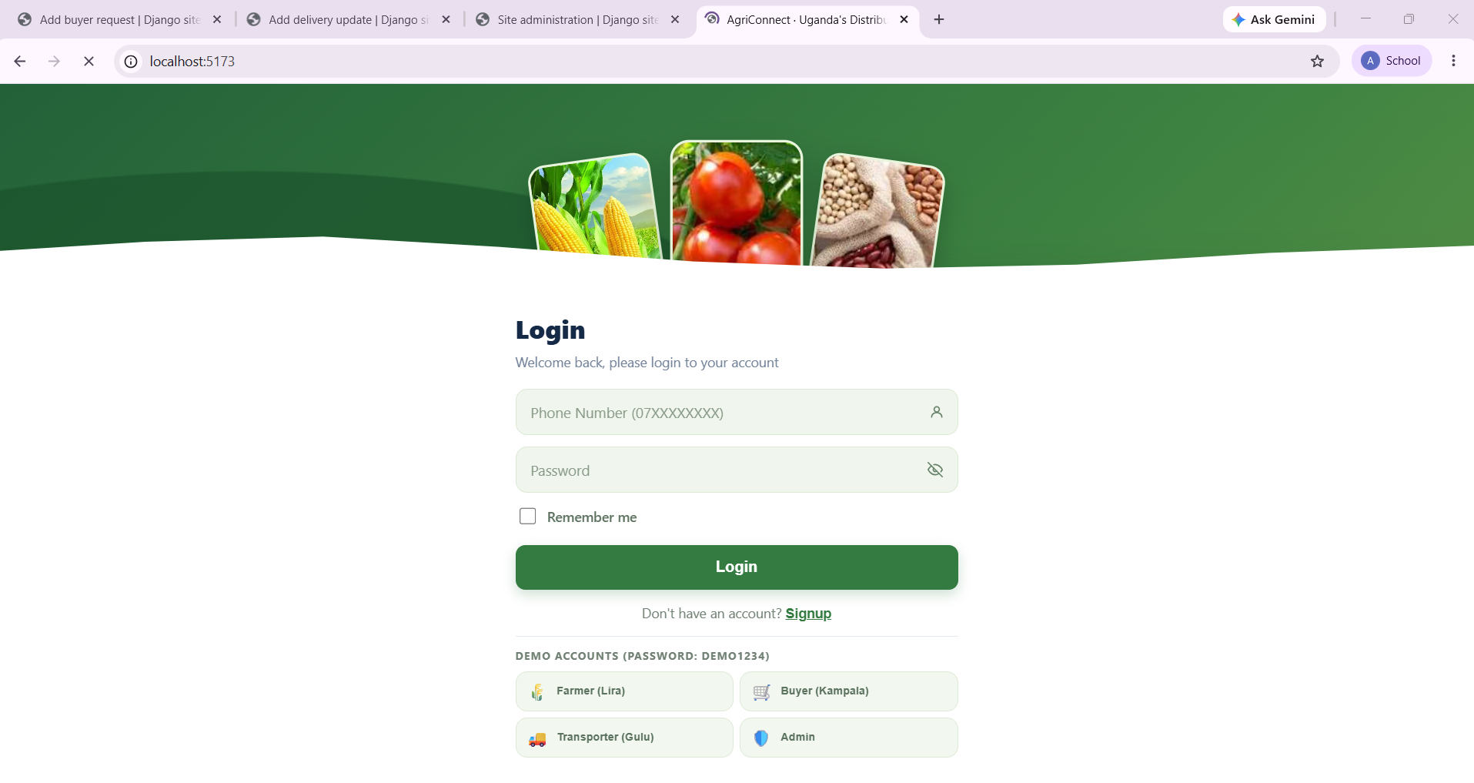
Figure 2. The sign-in screen served by the React client at localhost:5173, with one-click demo accounts for the four roles (farmer, buyer, transporter, admin).

3. Coordination and consistency
The hard part of a shared marketplace is that two people can act on the same record at once. We solved this in the database rather than in the application, because an in-memory lock inside one Django process would be invisible to the other process.
Accepting a purchase request. The API opens a transaction and locks the request row with select_for_update. It checks the request is still pending, then reduces the listing's stock with a single conditional update that only succeeds if quantity_available >= requested_quantity, using an F() expression so the subtraction happens inside the database. If another request has already used up the stock, the second acceptance is cancelled and the API returns HTTP 409 instead of overselling. The order, request status, notifications and event record are written in the same transaction.
Claiming a delivery. This is a compare-and-set: only a delivery whose status is open can change to accepted and receive a transporter. The number of rows updated decides the winner, and the loser receives HTTP 409.
Order status changes. These take a row lock and check an explicit list of allowed transitions, so an order cannot jump backwards or skip steps.
These guarantees rest on the database's transaction behaviour. SQLite serializes writers, which is enough for our single-laptop demo; a multi-host deployment would need PostgreSQL, which handles row-level locking across many connections.
Evidence. Two automated tests exercise these paths. The first creates competing requests against five units of stock and checks that only one four-unit order can be accepted. The second tries to assign the same delivery to two transporters and checks that the first claim stays and the second is rejected. Both run as sequential API calls against stale state; we have not run a true multi-machine race benchmark, and we do not claim to have.

4. Fault handling and reliability
AgriConnect survives the loss of one API process, and tells the client honestly when it cannot serve anything. It does not survive the loss of the load balancer, and it can lose a few seconds of writes if the local database dies suddenly.

4.1 When an API node fails
Each Django node has a health endpoint (/api/v1/health/) that runs a SELECT 1 against its database, so "healthy" means the node can actually reach its data, not merely that the process is running. The load balancer probes both nodes about once a second, sends traffic to the primary while it is ready, moves to the standby when the primary stops, and returns to the primary when it recovers. By default a node that does not answer within twenty seconds is marked unhealthy, which allows for slow database-backed checks.
The balancer retries on another node only when the first node refuses the connection, meaning the request never reached it. It never replays a request that may already have been processed. That choice prevents duplicate writes such as a double order, at the price of returning an error for some requests that fail halfway.
The failure sequence we demonstrated was:
- Both nodes ready: requests go to the primary.
- Primary stopped: the standby serves a health request.
- Both nodes stopped: the balancer returns HTTP 503, an explicit unavailable response.
- The database queried directly still answers SELECT 1, so the data stays intact while the application is down.
The last point matters: a healthy database does not serve the web application. With both nodes down, users see nothing until a node is restarted, because there is no automatic restart and no offline queue. The repository also includes npm run test:failover, which exercises slow health checks, failover, recovery and the all-nodes-down response automatically.
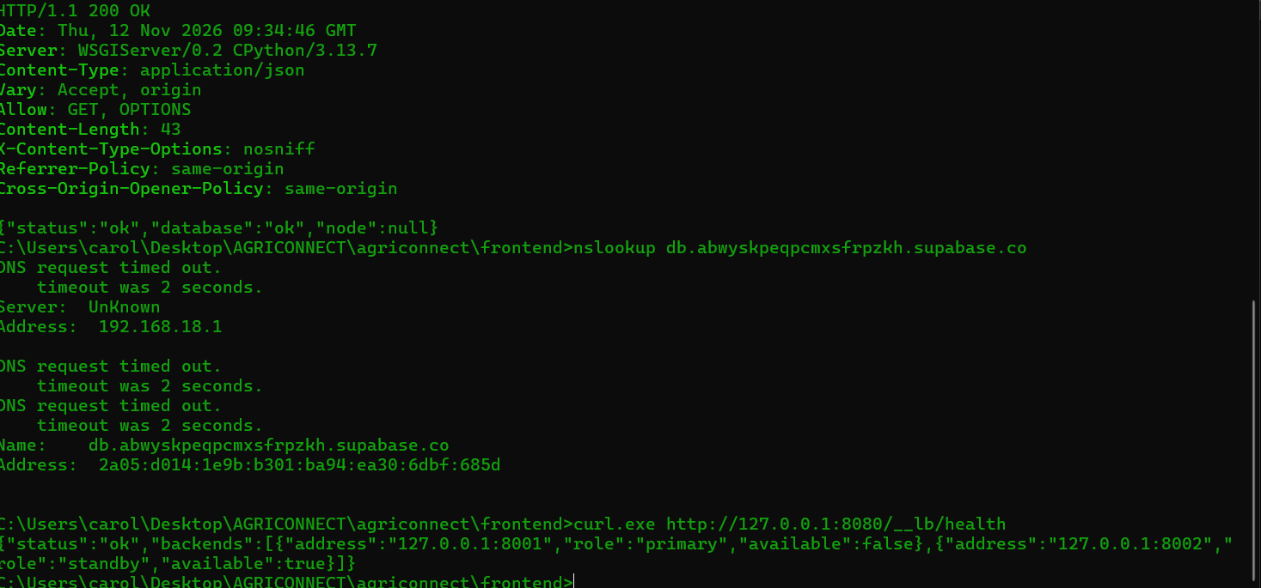
Figure 3. Failover evidence. With the primary node stopped, curl http://127.0.0.1:8080/__lb/health reports the primary (port 8001) as available: false and the standby (port 8002) as available: true, so traffic is served by the standby. The line above it shows a node health response, {"status":"ok","database":"ok"}, confirming database readiness.

4.2 When the database fails
Both nodes share a local SQLite file as the primary database. A background worker (run_database_backup) copies it to Supabase PostgreSQL every 15 seconds. If the local database fails, the first node to notice switches requests to Supabase and records the choice so both nodes follow. The system stays on Supabase after the local database recovers until an operator runs failback_to_local, which merges cloud-side changes back into local, refreshes the backup and switches back. A conflict report is written after setup and after failback. Local records win when unique records conflict.
We have not measured how long this switch takes, so we make no recovery-time claim for it.

4.3 Limits
- Possible data loss. Changes made since the last successful sync (up to about 15 seconds of activity) may be missing from Supabase if the local database fails suddenly.
- Single proxy. The Node.js load balancer is itself a single point of failure.
- Single machine. In the demo all processes share one laptop, so power or operating-system failure takes everything down.
- No recovery tooling. There is no automatic API restart and no queue for requests sent during an outage.
- Backups need configuring. Supabase point-in-time recovery must be enabled separately; the sync worker is not a substitute.

5. Performance evaluation
At ten concurrent clients the system handled all 100 requests without a failure and delivered about 109 requests per second, but each request took five times longer than when a single client had the system to itself.

5.1 How we measured
The script backend/load_test.py (standard library only) sent 100 read-only requests to the load-balanced health endpoint, once with one client and once with ten concurrent clients. That endpoint answers only after a database readiness query, so each request exercises the proxy, a Django node and the database. Both Django processes and the proxy ran on the same laptop, using a separate shared SQLite file (config.local_performance_settings), so no cloud or production data was touched. Times are wall-clock latencies seen by the client.
Machine: Windows 11 (build 26100), Intel Core i5-7300U at 2.60 GHz, 8 GB RAM, Python 3.13.7, Node.js v24.14.1. The Django development server was used, not a production server.

5.2 Results
Clients | Requests | Successful | Failed | Mean | P50 | P95 | Max | Throughput
1 | 100 | 100 (100%) | 0 | 10.90 ms | 9.58 ms | 15.98 ms | 97.72 ms | 90.65 req/s
10 | 100 | 100 (100%) | 0 | 55.32 ms | 48.94 ms | 114.86 ms | 233.82 ms | 109.34 req/s

5.3 What the numbers mean
With ten clients, mean latency rose from 10.90 ms to 55.32 ms and the 95th percentile from 15.98 ms to 114.86 ms, while throughput rose only from about 91 to 109 requests per second, a gain of roughly 20%. Ten times the clients did not give ten times the work done. That is expected here: every client, both API nodes, the proxy and the single SQLite file compete for one slow laptop, so extra clients mostly wait in line. The maximum latencies depend on operating-system scheduling and should not be read as a guarantee.
These results describe read-only health traffic on a development server. They do not cover writes, image uploads, order contention or real internet latency. A separate, informal attempt against the Supabase database gave highly variable response times and client timeouts, so we left it out of the table. It should be repeated from the deployment region with a larger controlled sample before we say anything about cloud capacity.

6. Testing and demonstration

6.1 Automated tests
The isolated Django suite has six tests and all six pass. It uses an in-memory SQLite database (config.test_settings), so it never touches the configured cloud database. The tests cover:
- Health reports ready when the database is reachable.
- Health reports not ready when the database is unavailable.
- Public registration rejects the administrator role.
- Role authorization returns 403 where it should.
- Competing purchase acceptance (five units, one four-unit order wins).
- Competing delivery claims (first claim kept, second rejected).
Run them from backend:
..\.venv\Scripts\python.exe manage.py test agri.tests --settings=config.test_settings
The React production build also completes successfully.
.

Appendix: commands for test evidence
These commands from the README produce the logs and screenshots the brief asks for. The README is the full reference for setup.
curl.exe http://127.0.0.1:8080/__lb/health
curl.exe http://127.0.0.1:8001/api/v1/health/
curl.exe -i http://127.0.0.1:8080/api/v1/locations/crops/
cd backend
..\.venv\Scripts\python.exe load_test.py --requests 100 --clients 1,10
The first shows load balancer health, the second a single node's database readiness, and the third the response headers that name the node that served the request. The last reproduces Table 5.2.

Startup evidence
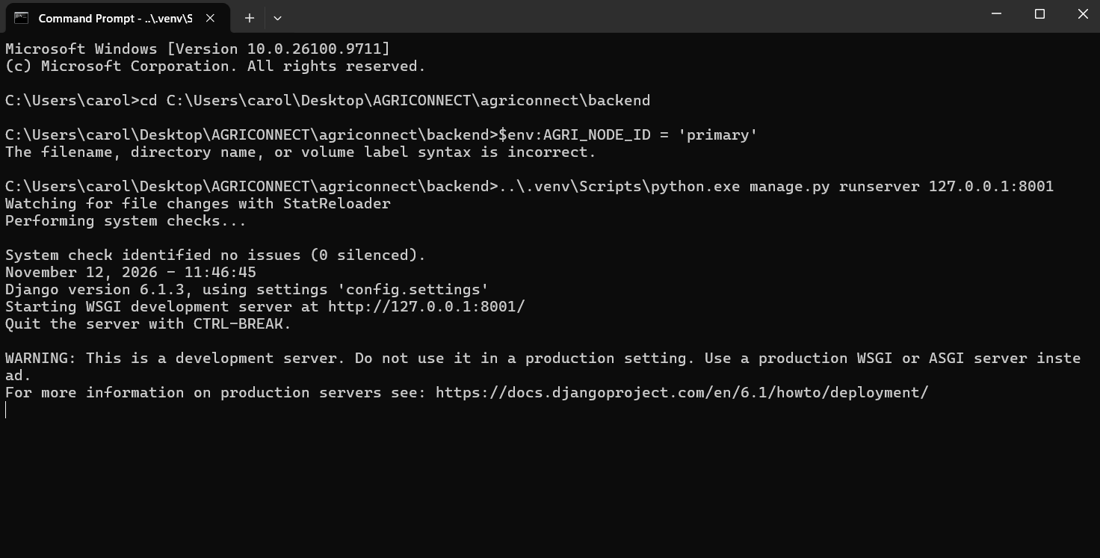
Figure 4. Primary API node (AGRI_NODE_ID primary) started with runserver 127.0.0.1:8001. Django's system check reports no issues.
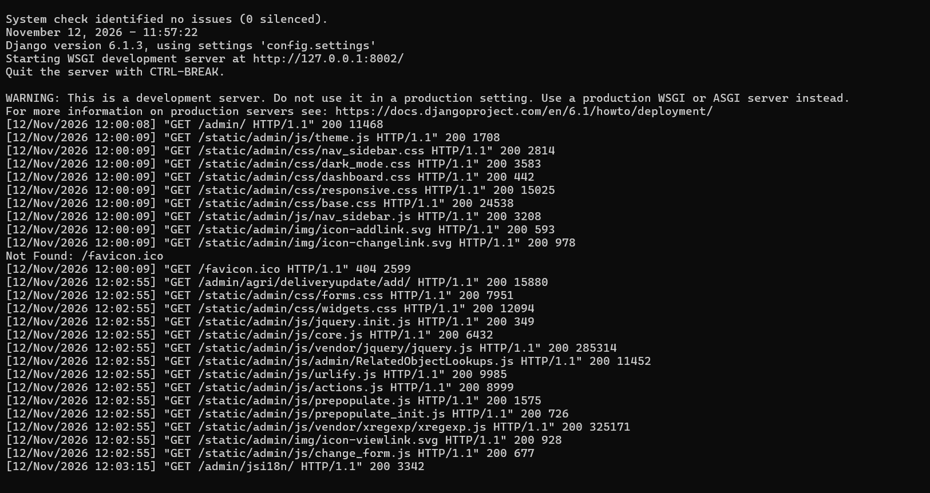
Figure 5. Standby API node running on port 8002 and handling requests (HTTP 200 responses in its log).
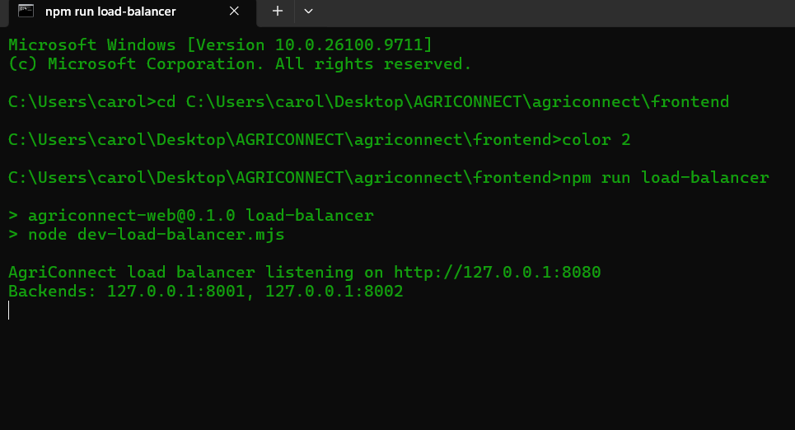
Figure 6. The Node.js load balancer listening on 127.0.0.1:8080 with backends 8001 and 8002 configured.
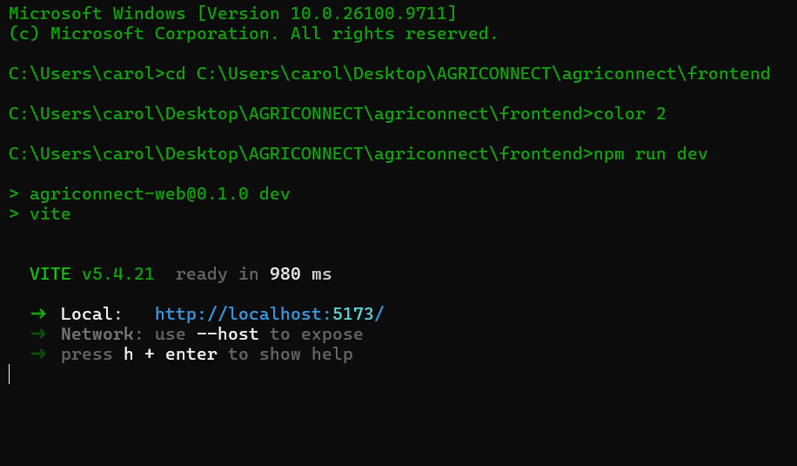
Figure 7. The React/Vite frontend ready at http://localhost:5173/.

